**Analysis Of Queuing of Yo Korean Bubble Tea & Chicken - Imus with Simulation Approach**

*Talavera, Harold Jay*

*Department of Computer Studies*

*Technological University of the Philippines*

*Manila, Philippines*

*Dela Cruz, Michael Joshua*

*Department of Computer Studies*

*Technological University of the Philippines*

*Manila, Philippines*

*Legaspi, Ernst Danielle*

*Department of Computer Studies*

*Technological University of the Philippines*

*Manila, Philippines*

*Cabarles, Ryan*

*Department of Computer Studies*

*Technological University of the Philippines*

*Manila, Philippines*

***Abstract*** Queues in the cashier area in food purchases is one of the problems that often occurs in business processes in the community. Queues occur because of an imbalance between those served and their services. In fast food restaurants like Yo Korean Bubble Tea & Chicken, queues generally occur during lunch breaks or at dinner time. The purpose of this study is to determine the queuing model that occurs in the Yo Korean Bubble Tea & Chicken cashier area and analyze whether the queuing model is appropriate and efficient by comparing the previous model with the simulation results that have been carried out with the help of Anylogic software. The restaurant queue system is 3 queue lines and 3 counters. Preliminary observational data show the average service time counters 1, 2 and 3 are 111, 136, 138 seconds. This fact shows that there is a long queue, the number of customers served at relatively low time units and work imbalances between operators. The results of the best queue simulation are proven to have shorter queues and the highest number of customers served per unit time. Based on the simulation results obtained by replacing 3 queue lines into 1 queue line and increasing the number of customers served is 86 people from 100 customers with the percentage of customers at each counter that is 32% for counter 1, 42% for counters 2 and 26% for counter 3.

1. INTRODUCTION

Increased public interest in consuming fast food can cause its own problems for fast food businesses [1]. The problem that can be investigated from the increased interest of the community lies in its queuing system. The process of queuing into something is less favored by the people of Imus. This is also an obstacle experienced at Yo Korean Bubble Tea & Chicken. The number of fast-food enthusiasts cause long queues [2]. This condition causes a condition where the productivity of the fast-food restaurant decreases. In the Yo Korean Bubble Tea & Chicken store queue system there are 3 queue lines with a total of 3 service counters. Based on observations, the average service time at counter 1 is around 111 seconds, counter 2 is around 136 seconds and counter 3 is around 138 seconds. The limitation of this study is the amount of data as much as 100 data where at the time of observation counter 1 served 45 customers, counter 2

served 39 customers and counter 3 served 16 customers with a queue of about 3-7 people each. The

queue itself is a line formed by the process of waiting in a system to get a thing or service [3]. Some queuing models commonly used in fast food restaurant are first in first out, last in first out, and random order in service [4]. Under these conditions it is necessary to design improvements to optimize the queue system to reduce the number of queues and the idle time of each counter. Repairing the queuing system is done by identifying the type of arrival time distribution and the length of service. With known types of arrival time distribution and length of service, we can determine the optimal queuing system model by simulating it with available simulation software.

Simulation is a technique that uses the help of computer devices to mimic the processes contained in a system [5]. Simulation determines whether a system is in accordance with systems that exist in the real world. Simulation can be a prediction of events that occur and can be collected data needed [6].

Many studies of the queuing system have been done. But there is rarely research on queuing systems using anylogic software [7]. Different from other software Anylogic software can show the number of customers served at a certain time unit. In this study the simulation software used is Anylogic Software. Anylogic is a multimethod simulation modeling tool developed by The Anylogic Company that can be used for dynamic systems, discrete events and agent based. This research was also assisted using easy fit software in identifying the distribution of service length and arrival time at Yo Korean Bubble Tea & Chicken food restaurant. The use of these two software allows the determination of an optimal queue model for Yo Korean Bubble Tea & Chicken fast food restaurant.

1. METHODOLOGY

The stages of research conducted at Yo Korean Bubble Tea & Chicken fast food restaurant are as follows:

1. *Data Collection*

Data collection is used to identify the type of distribution that exists in the queuing system at the Yo Korean Bubble Tea & Chicken food restaurant that are used as important data so that it can be simulated in

Anylogic Software. The data used is the arrival of customers, the length of time of service and the length of time the customer moves to the service. Data was collected by direct observation at Yo Korean Bubble Tea & Chicken food stalls during work time. Data to be taken is the average time of service / process.

1. *Creating a System Description*

The system is designed using Anylogic Software so that the system designed can reduce the number of queues and idle time per counter.

1. *System Design*

The stages in designing this system consist of:

1. Distribution Testing

Distribution testing is performed on the old service data and the time interval of arrival that has been collected during the observation.

1. Making a Queue System Simulation

At this stage the most optimal queuing system simulation is made using Anylogic Software according to the type of arrival time distribution and customer service length.

1. RESULT AND DISCUSSION
2. *Service / Process Average Time Data*

Data on average time of service at Yo Korean Bubble Tea & Chicken food restaurant can be seen in Table 1.

**Table 1. Data on Average Time of Service at Yo Korean Bubble Tea & Chicken Fast Food Stall**

|  |  |
| --- | --- |
| Process | Average Time(seconds) |
| Duration of Service Counter 1 | 111 |
| Duration of Service Counter 2 | 136 |
| Duration of Service Counter 3 | 138 |

In table1 based on the observation data that has been collected on Yo Korean Bubble Tea & Chicken Fast Food Restaurant in total of 100 sampling data. Preliminary observational data shows the average service time counters 1, 2 and 3 are 111, 136, 138 seconds.

1. *Making a Queue System Simulation*

At this stage the most optimal queuing system simulation is made using Anylogic Software according to the type of arrival time distribution and customer service length. Simulation results with 2D and 3D Anylogic Software can be seen in Figure 1 and Figure 2.

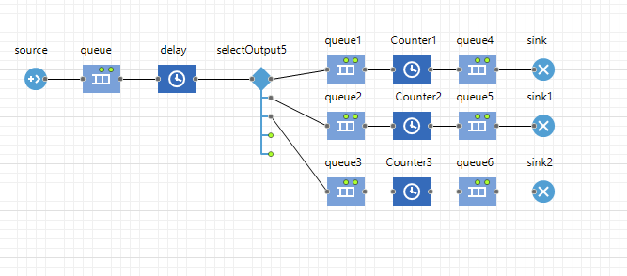

**Figure 1. Simulation Results with 2D Anylogic Software**

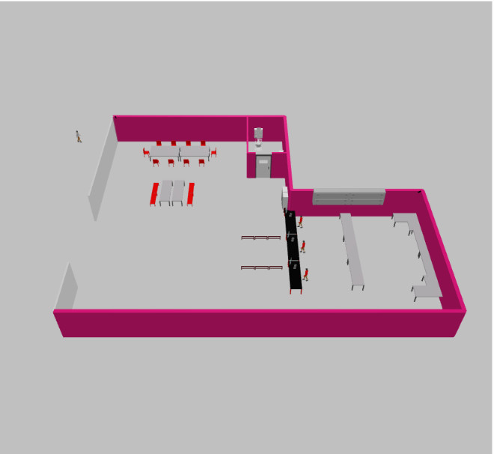

**Figure 2. Simulation Results with 3D Anylogic Software**

1. *Test the system*

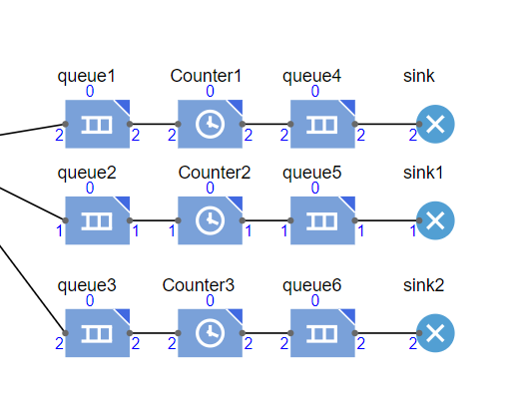After simulation with Anylogic Software with 3 queue lines and 3 counters (can be seen in Figure 3), the result is that the total number of customers served is 5 customers with 40% of customers served at counter 1, 20% are served at counter 2 and 40% is served at counter 3.

**Figure 3. Current System Trial Results with Anylogic Software**

Based on the results of the current system simulation with Anylogic Software, there are a small number of customers served, causing long queues. This shows that the Yo Korean Bubble Tea & Chicken fast food restaurant have long queues.

1. *Testing of Simulation System 1*

The simulation system trial 1 was conducted by changing 3 queue lines to 2 queue line and reducing the number of counters from 3 to 2. The simulation results can be seen in Figure 4.

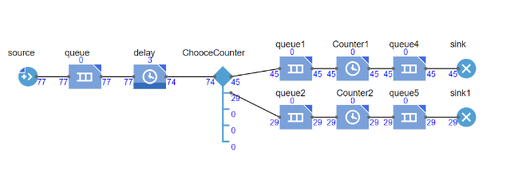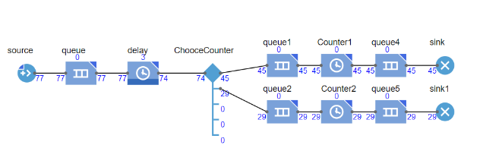

**Figure 4. Simulation Results of Test 1 with Anylogic Software**

According to the simulation results obtained using Anylogic Software that the number of customers served by 77 people from 100 customers with a percentage of customers at each counter is 62% for counter 1 and 38% for counter 2.

1. *Testing of Simulation System 2*

Trial simulation 2 is carried out by means of 3 queue lines being changed to 1 queue line with 3 counters. Simulation results can be seen in Figure 5.

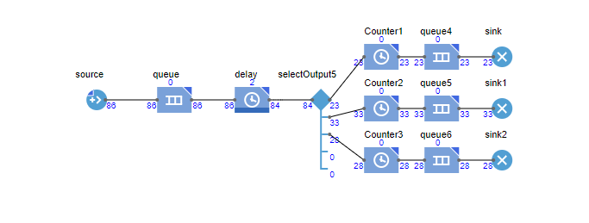

**Figure 5. Simulation Results of Test 2 with Anylogic Software**

According to the simulation results obtained using Anylogic Software that an increase in the number of customers served is as many as 86 people from 100 customers with the percentage of customers at each counter that is 32% for counter 1, 42% for counter 2 and 26% for counter 3.

1. CONCLUSION
2. Based on the results of the current system simulation with Anylogic Software, there are a small number of customers served, causing long queues. This shows that customers of Yo Korean Bubble Tea & Chicken fast food restaurant have long and long queues.
3. According to the simulation results obtained using Anylogic Software, simulation model is shown the number of customers served by 77 people from 100 customers with a percentage of customers at each counter is 62% for counter 1 and 38% for counter 2. Simulation model 2 is shown to have an increase in the number of customers served is as many as 86 people from 100 customers with the percentage of customers at each counter that is 32% for counter 1, 42% for counter 2 and 26% for counter 3.
4. Based on the Anylogic software it is shown that simulation model 2 using 1 queue line and 3 counters is the most optimize model of queue system for the fast-food restaurant.

**REFERENCES**

[1] Nelson B. L, Discrete event system simulation (Prentice Hall, 2001).

[2] Levine A. I., 2013 Healthcare Simulation: From “Best Secret” to “Best Practice”. The Comprehensive Textbook of Healthcare Simulation, pp. 3-4.

[3] A. Law, Simulation Modeling and Analysis Fourth Edition. (McGraw-Hill, 2007)

[4] Agrawal G. A. 2010 Queuing Model for Health Centre International Conference on Electronics and Information Engineering (ICEIE 2010) pp. 542-547

[5] Zhu H., Gong J., and Tang J. A., 2013 Queuing Network Analysis Model in Emergency Departments. 25th Chinese Control and Decision Conference (CCDC) pp. 1829-1834.

[6] Gang F.Y. and Hong F., 2014 A Simple Simulation Method for Queue System. Sixth International Conference on Intelligent Human-Machine System and Cybernetics, Hangzhou, pp. 177-180

[7] Jiang S.H and Fu X.L., 2008 Under Queuing Theory to Explore Supermarkets Service Model. Logistics Technology pp. 141-142

[8] Ratnasari S., Rahadian N., and Liquidannu E 2018. Pemodelan dan Simulasi Sistem Antrian Pelayanan Konsumen Gerai MCD Solo Grand Mall dengan Arena,” Pros. Semin. dan Konf. Nas. IDEC, pp. 7–8

[9] Hasian D P and Putra A K 2010 Simulasi pelayanan pengisian bahan bakar di SPBU Gunung Pangilun 9(1), pp. 31–36, 2010.

[10] Rahmat R F, Anthonius, Muchtar M A, Hizriadi A, Syahputra M F 2018 Virtual reality interactive media for universitas sumatera utara - A campus introduction and simulation Journal of Physics: Conference Series 978(1).

[11] Darmansyah S 2012. "Analisis Stasiun MRT Jakarta Dengan Pemodelan Berbasis Agen" Fakultas Teknik Universitas Indonesia. Depok.

[12] Hasugian I, Sidauruk P H, and Zalukhu A 2020 Evaluasi Ekonomi Teknik Pada Usaha Bengkel Las (Studi Kasus Bengkel Las XYZ, Medan, Sumatera Utara)”, Buletin Utama Teknik,15(2), pp. 190-195